creates a directory, and then creates an inventory file in the created directory

1.Go to Ansible Controller

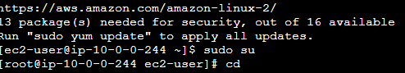

2.Create a new directory in any location of

the Ansible Controller.

CMD: mkdir name



3.Go toyour created directory.

Cmd: cd name



4.Create an inventory file with nameas hosts

Cmd: touch hosts



5.Create a group in hosts files and add the IP

address of ansible hosts in it

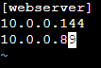

6.Write a new playbook –write-host details, become user details and add any tasks.

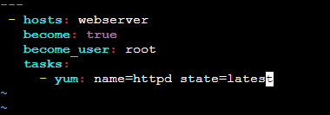

7.Execute the playbook by calling your inventory file and playbook.

Cmd: ansible-playbook –i hosts ha.yml

